**BioSite**

* **Front-end Style Guide**
* **Selected Google fonts**

<link rel="preconnect" href="https://fonts.googleapis.com">

<link rel="preconnect" href="https://fonts.gstatic.com" crossorigin>

<link href="https://fonts.googleapis.com/css2?family=Roboto+Condensed:wght@300&display=swap" rel="stylesheet">

font-family: 'Roboto Condensed', sans-serif;

* **Selected Color palette**
  + Tan #B68D40
  + Cream #F4EBD0
  + Charcoal #122620
  + Gold #D6AD60

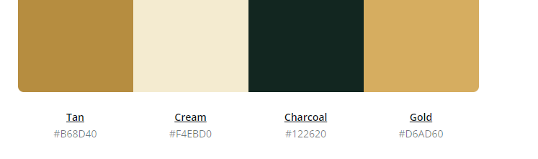

* **Note: You will need to create your own style guide from the examples provided under the “Resources” section.**
* **Wireframes, sketches, or prototypes**
* **Note: The deliverables here are wireframes, sketches, and/or prototypes of the proposed design. Outcomes from this task will be compared against the final submission and they must match.**

**Home**

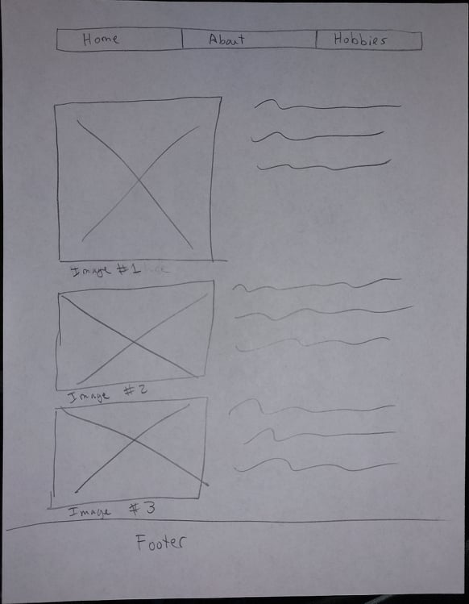

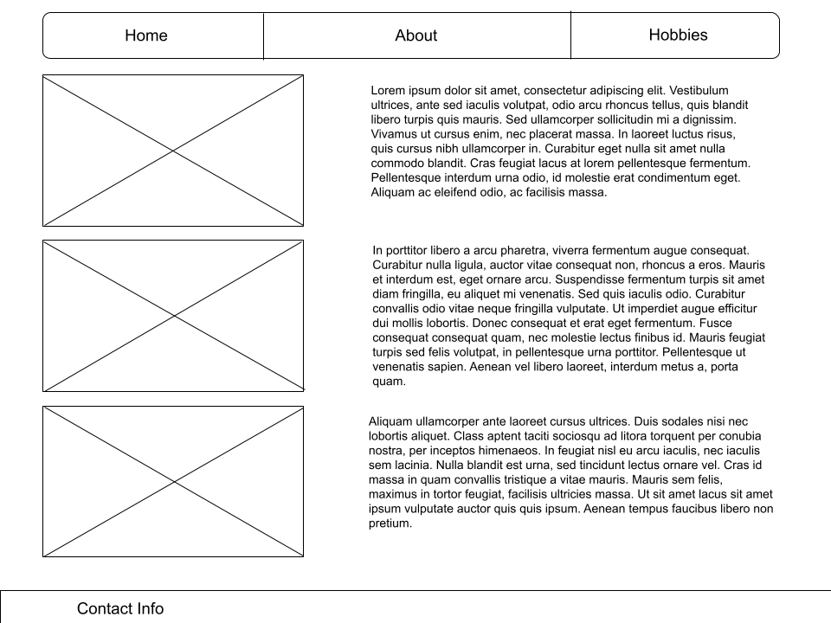

**About**

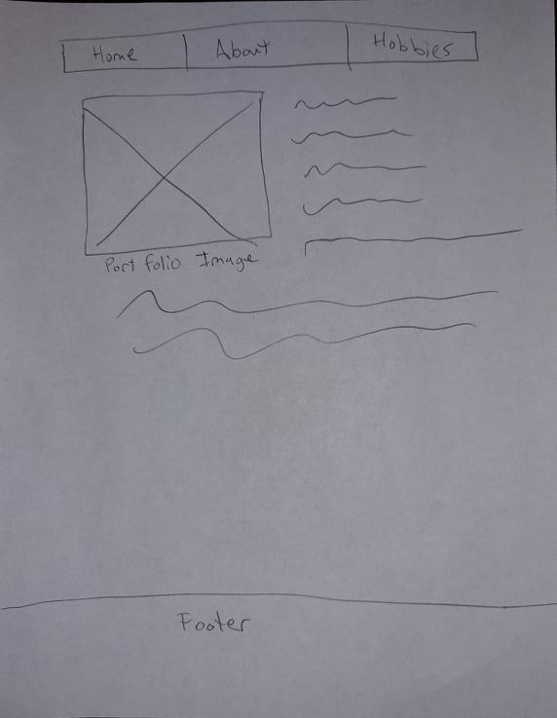

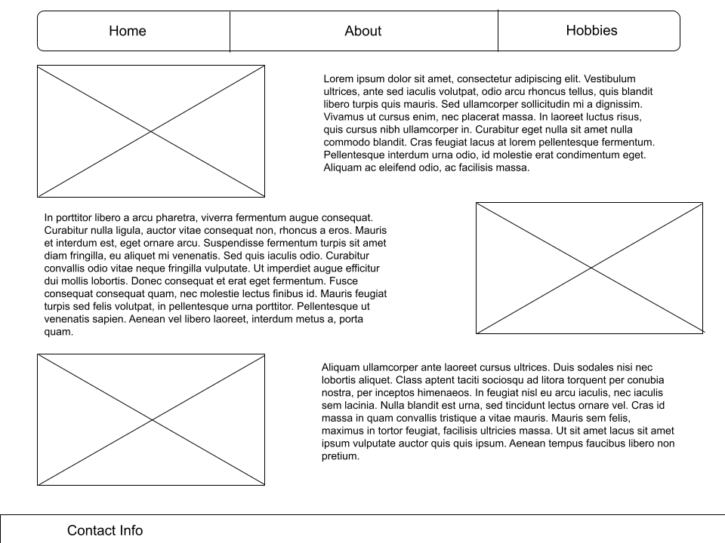

**Hobbies**

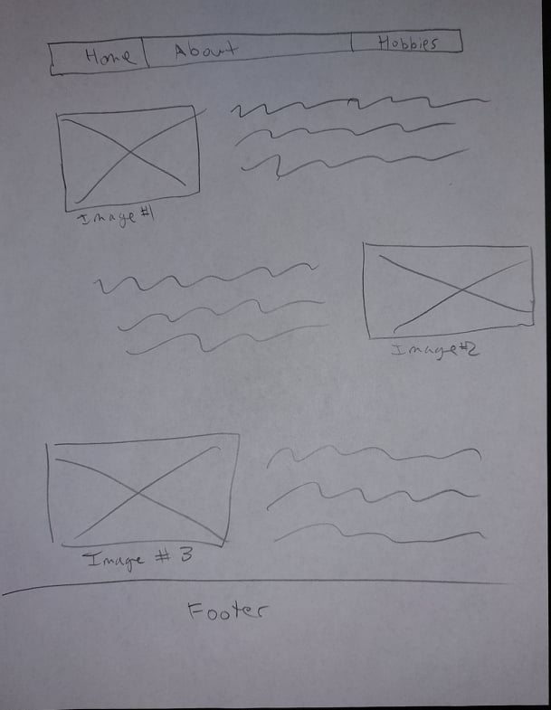

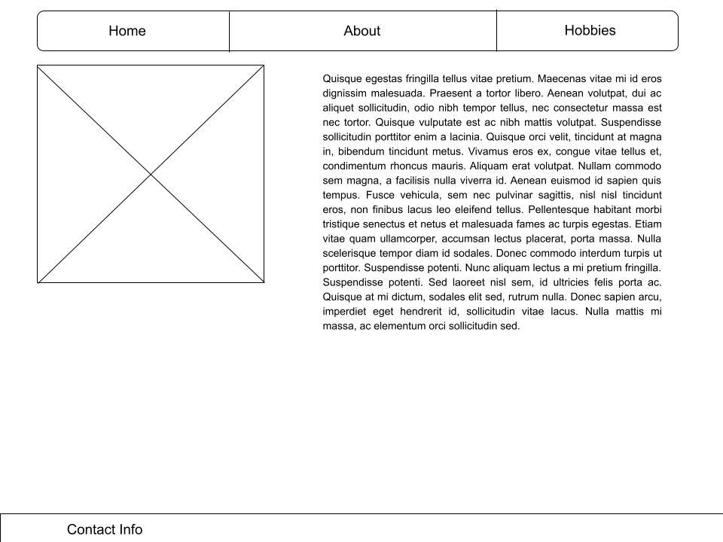

* **At least one completed interview of the subject (the document must contain a minimum of 10 interview questions and responses from the subject).**

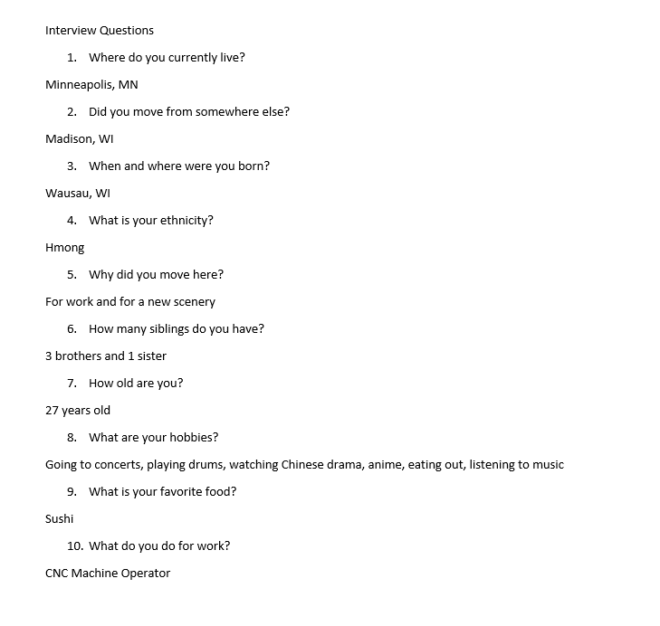

* **One page (minimum 250 words) inspiration document containing all of the research you completed to gain a better understanding of the subject and their hobbies.**
* The type of concerts that he likes to go to are indie music or also known as independent music. He also likes a mixture of other genre such as metal and rock. But the majority of the concerts that he goes to are instrumental band concerts. What this means is that there are no singing involve. The band only plays music with a electric guitarist, bass guitarist, and drummer. There are usually around four to six musicians in the band. The bands that he usually goes to the concert to are Polyphia, Chon, Intervals and Animals As Leaders. At the concerts like these, there is usually a mosh pit around the center of the concert area. Here in the mosh pit, the audience would aggressively dance, jump, and bump each other. They also push each other around while still dancing to the music. Mosh pit is something that does not happen all the time at these concerts as it is dependent on the concert location. If the venue does not have the allocated space, the bouncers or security for the venue will not allow the mosh pit to happen.
* He likes to play drums on his free time. The type of music that he likes to play are the same as the concerts he attends locally here in the Minneapolis area. He has an electric drum kit along with an acoustic drum kit. Both drum kits are of high quality and are expensive. He only plays for fun and does not have a band to play with. He also has many custom drum snare that he has purchased for himself. A snare is what a music band would be playing such as during a parade or at a football game.
* Watching Chinese drama is something he likes to do a lot. These drama are mainly ancient Chinese drama based on fictional times where they can fly, jump, and sometimes can cast magic. He mainly likes to watch dramas that have fighting in them. These drama usually have about 60-90 episodes with each running about 40 minutes each. He has been watching Chinese drama since he was in High School. He was watched about 35 Chinese dramas up to this day.
* **One page (minimum 250 words) document containing a short bio of the subject**
* **This is a formalized write-up of the subject and will be used in the final project**
* **This should be the outcomes from the interview and research you conducted on the subject and their hobbies**
* **This will be added to the About page**

Luke Her is of first Hmong generation whom had come to the United States after the Vietnam War in 1975. Luke has three brothers and one sister. He is the second youngest with the youngest being his brother. He graduated from High School in 2012 from Stevens Point WI. He got his CNC Certification in 2015 and first moved to Madison WI for work due to having good network with his instructor. He decided to be a CNC Machinist due to having a liking to working in his Tech Ed classes during his Junior High and High School days. He firmly believes that his profession is of high value and that there are not enough people interested in such a high demanding profession. While in Madison, he lived there for a year and a half by himself until his older sister moved there to do an internship. After he had finished his two year experience in Madison, he decided to move back to Minneapolis. The reason for his move so suddenly was because of there were no relatives nor family in Madison. He felt very lonely in Madison and decided to move to Minneapolis because there were much more family in the Twin Cities area. The cites also offer more concerts for him to go to because it was a hot spot for the indie bands to tour through rather than Madison.

His hobbies did not fully come to life until he was in Madison and had an budget to fully explore his hobbies. While he was in school to become a CNC Machine Operator, he did not have the funds to purchase a good drum set. After a few months in Madison with a good income, he purchased many things such as an expensive drum kit that was of high quality. He also started to explore boutique drum brands in the local area of Madison. Upon moving to Minneapolis, he continued to purchase other drum equipment and an electric drum kit due to living in an apartment. To this day, he continues to visit the local drum shops and also buy other drum accessories.

Achievements

Went to College Twice

1. The first time Luke went to college, he went to a technical college to get his welding technical diploma in 2014. Upon finishing school he went straight into the work force in a local manufacturing company that welded parts together. He started two weeks upon finishing school and worked on second shift. He continued to work there for another until the following summer of 2015. After one year of working as a welder, he had decided that welding was not something that he wanted to do because of a few negative factors. He then decided to change career and went back to school to do another profession that pays more and has less strain on his body. This is where he continued his education and got his Machine Tool Technical Diploma in spring of 2016. The program only took a school year for him to complete because he had already taken most of the prerequisites when he went for welding.

Moved to a New City Twice

1. When Luke completed his welding diploma, he remained home with his parents and worked in at a company located five minutes away. Like most young folks who still lived with their parents, there were limitations. After he graduated with his Machine Tool diploma, he decided to move to Madison Wisconsin. Stevens Point is a fairly small city compared to Madison. Stevens Point has about twenty six thousand population and Madison has a population of two-hundred and fifty-four thousand. Smaller cities are limited in compare to larger cities. Madison was almost ten times the size of Stevens Point. He lived in Madison with a new beginning while finding a new community and new friends for two and a half years. He then decided to move to the Minneapolis area. An area that was twice the size of Madison which had a population of four-hundred and twenty thousand. He has remained in the Minneapolis area for the past two years and does not plan to move. In both Madison and Minneapolis, he had to find a new community and new friends as he did not know many people in either of the cities.

Change in Career

1. Luke did not enjoy his time as a welder. There were many things that he did not like that the job after a year. There were a few things that concerned him as he reached his one year mark. First was the light from when the weld would happen. He was concern that the light would eventually render him partially blind due to constantly looking at the flash when welding. This is called “welding flash” where a welder can suffer from if they are exposed to the ultraviolet light from the weld. Second, he always smelled of metal due to the work environment that he was in. There were always debris of metal on his clothes after a long day work. Third, the welding gun torch had taken a toll on his hand. Due to long exposures of holding the welding gun for hours at a time for an entire year, his hand had become cramped to the shape of holding a welding gun. Even when he slept, his hand would hold the muscle memory of that shape. He also couldn’t play the drums due to this condition. This is called carpal tunnel. After completing his Machine Tool Technical Diploma in 2016, he had become a CNC Machinist. The job took less strained from his body such as not having to look directly into a ultraviolet light, having carpal tunnel while holding the welding gun, and having less of a metal smell. The job required less and the pay was more.

* **The images you intend to use in the final project**
  + **3 Images should be related to the subject's hobbies**

Photo by [Michal Balog](https://unsplash.com/@mikbutcher?utm_source=unsplash&utm_medium=referral&utm_content=creditCopyText) on [Unsplash](https://unsplash.com/s/photos/college?utm_source=unsplash&utm_medium=referral&utm_content=creditCopyText)

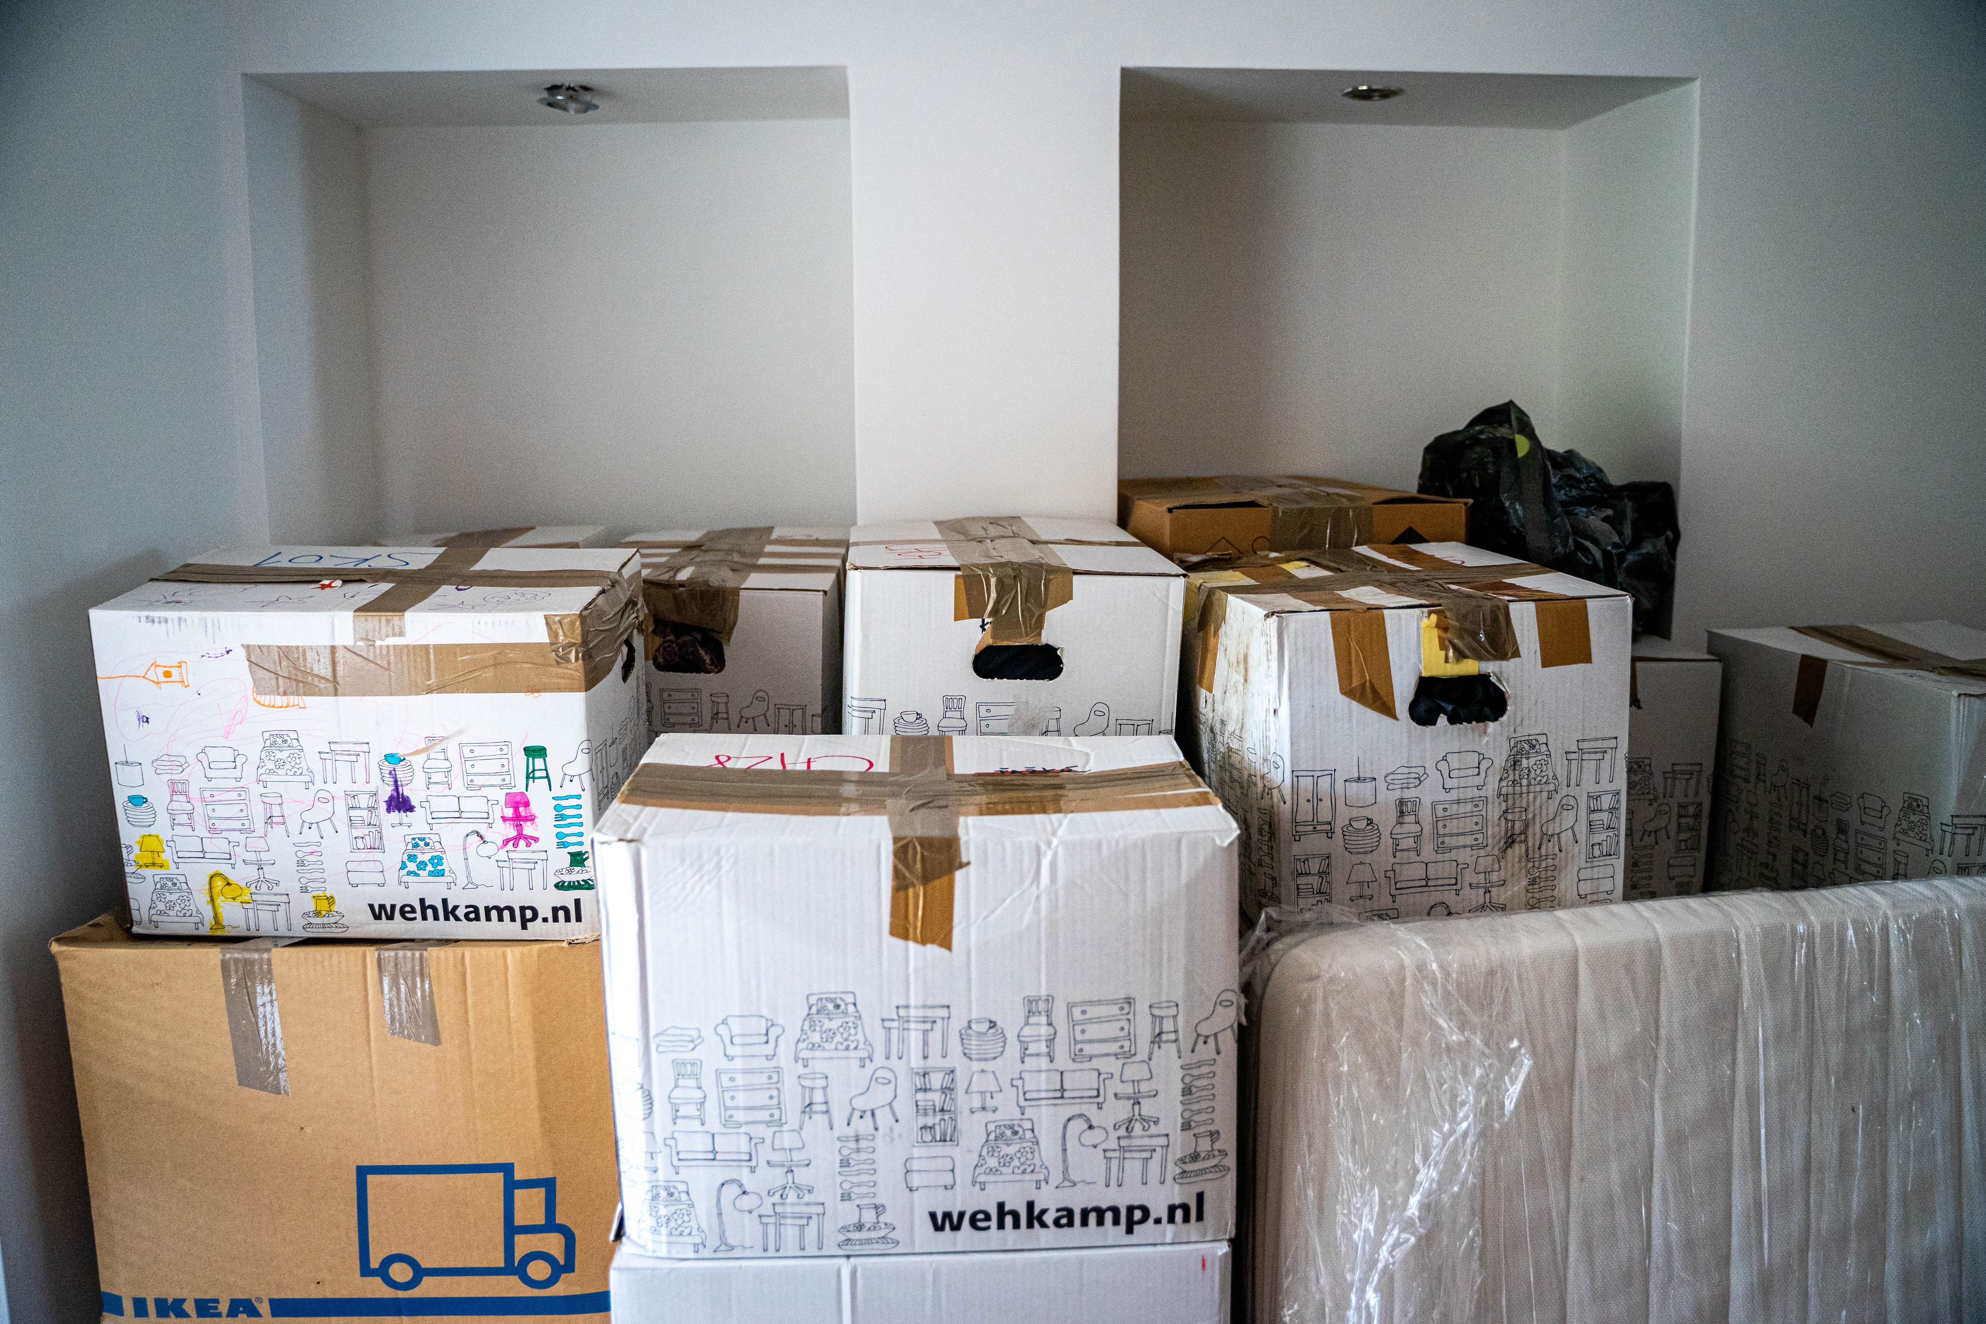

Photo by [MD Duran](https://unsplash.com/@mdesign85?utm_source=unsplash&utm_medium=referral&utm_content=creditCopyText) on [Unsplash](https://unsplash.com/s/photos/college?utm_source=unsplash&utm_medium=referral&utm_content=creditCopyText)



Photo by [Greg Rosenke](https://unsplash.com/@greg_rosenke?utm_source=unsplash&utm_medium=referral&utm_content=creditCopyText) on [Unsplash](https://unsplash.com/s/photos/cnc?utm_source=unsplash&utm_medium=referral&utm_content=creditCopyText)

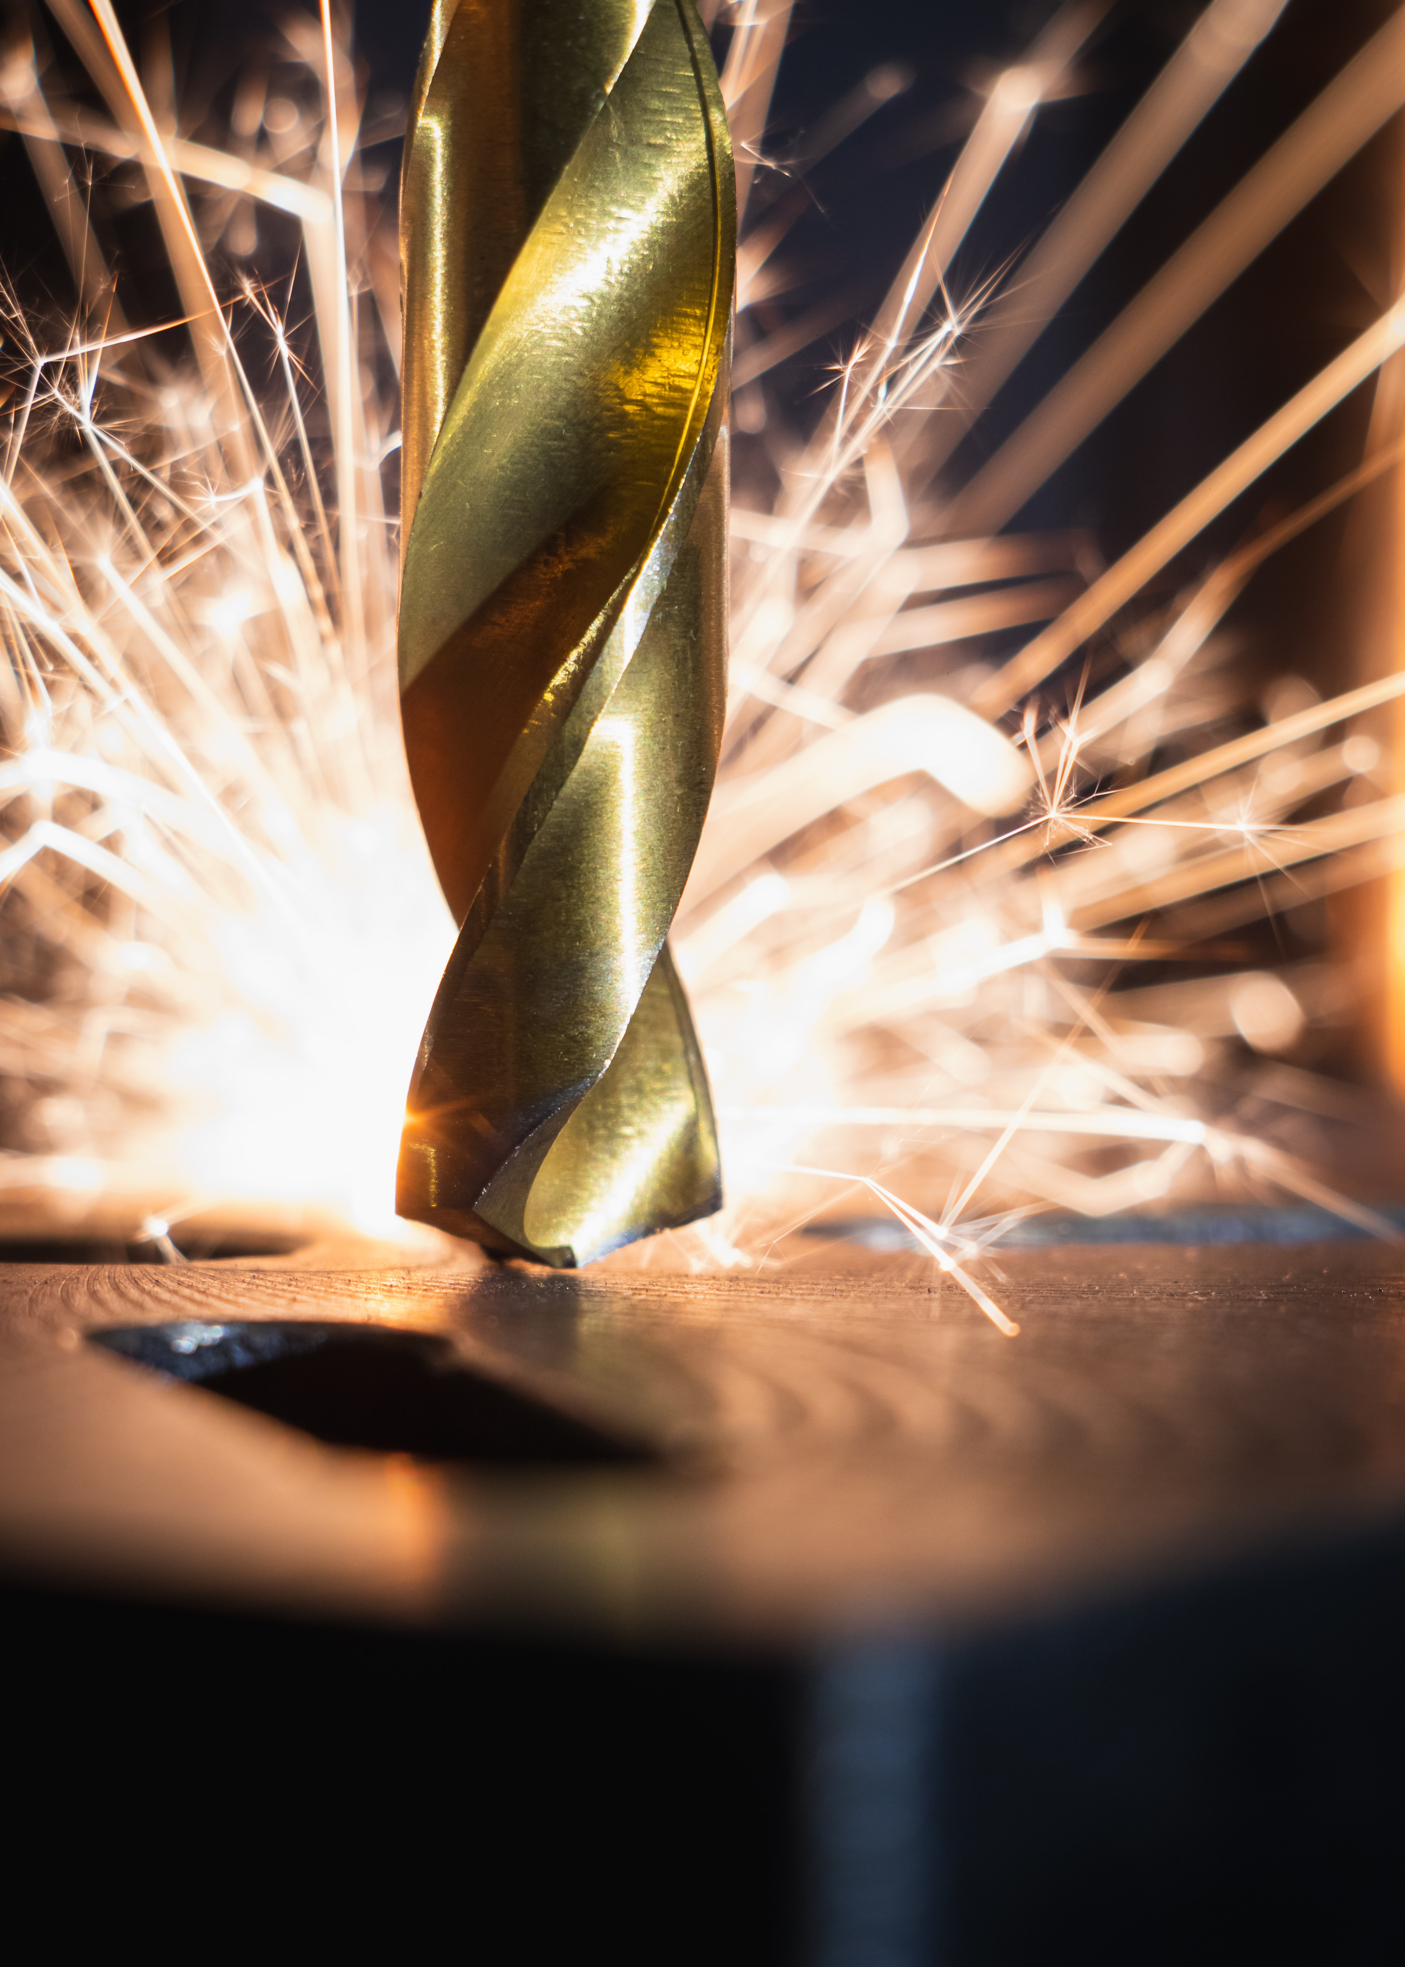

* + - **This will go under the hobby page and should include a small write-up explaining their relevance. Remember, you are trying to build a story/timeline for visitors to follow**
  + **3 images should be related to the subject’s goals, personal accomplishments, or embellishments**

**Photo by zhang kaiyv from Pexels**

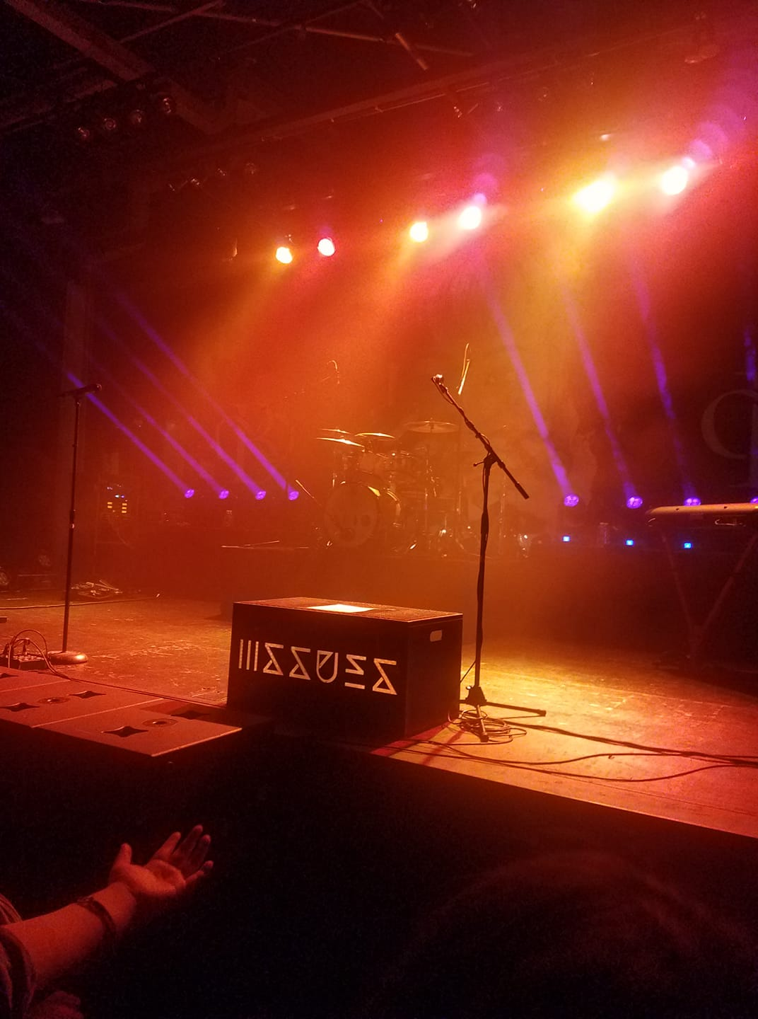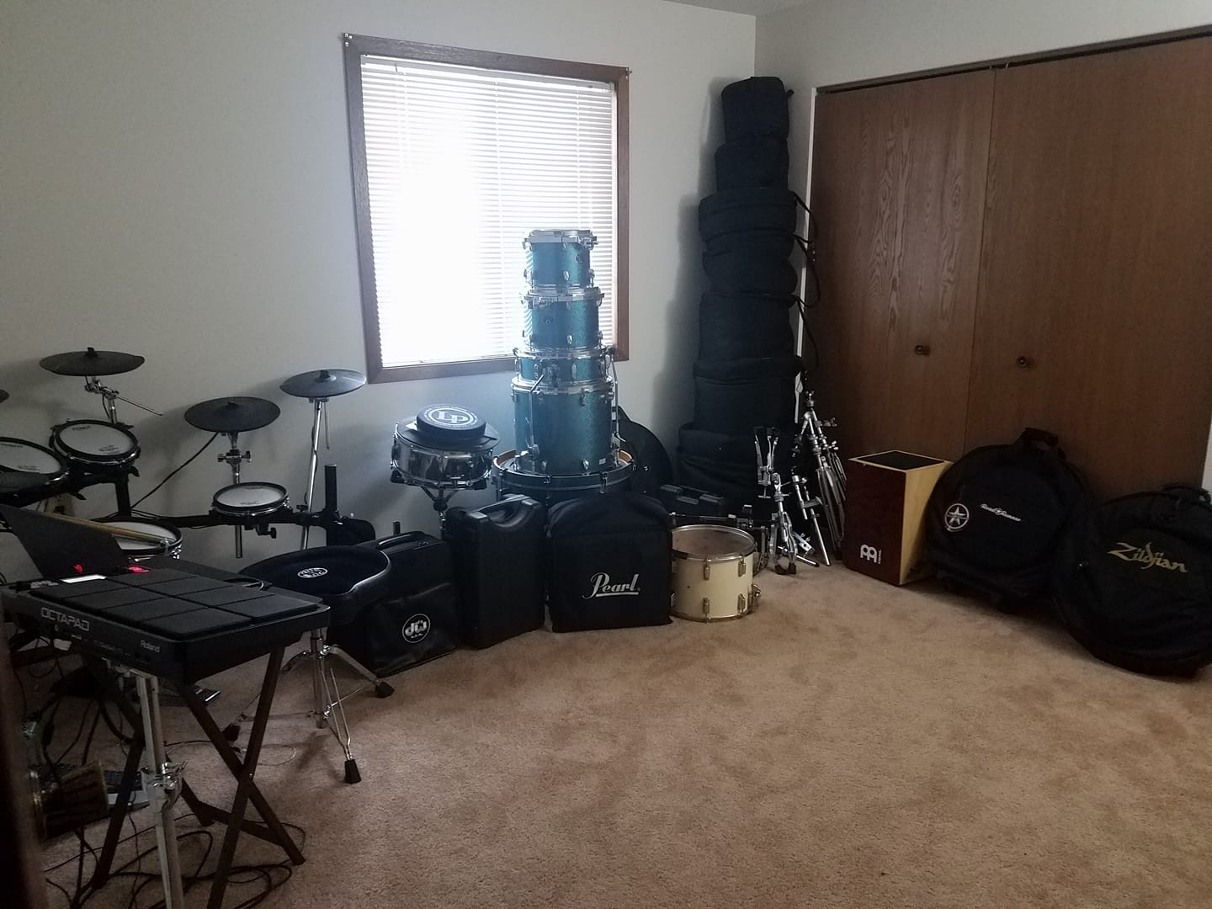

* + - **These will go on the landing page and should include a small write-up explaining their relevance. Remember, you are trying to build a story/timeline for visitors to follow**
  + **1 image should be a portrait of the subject**
    - **This image will be added to the About page, above the formalized 250-word write-up**

